Energy crisis in Europe revamps the economic competitiveness of green chemicals
Abhinandan Nabera, Ioan-Robert Istrate, Antonio José Martín, Javier Pérez-Ramírez and Gonzalo Guillén-Gosálbez*
Institute for Chemical and Bioengineering, Department of Chemistry and Applied Biosciences, ETH Zürich, Vladimir-Prelog-Weg 1, Zürich 8093, Switzerland
*Corresponding author: gonzalo.guillen.gosalbez@chem.ethz.ch

Abstract
Ammonia and methanol are necessary platform chemicals used as raw materials for producing many valuable products. Both these chemicals use natural gas as feedstock and fuel, resulting in higher CO₂ emissions and vulnerability to supply disruption. Extensive research has been conducted to identify alternative production routes based on renewable feedstocks, but the relatively higher costs are bottlenecks. Here, we show how an unprecedented crisis of soaring energy prices in Europe could radically change the current landscape and improve the economic competitiveness of green ammonia and methanol. In addition to emitting less CO₂, we found that some green production routes were cost-competitive and, in some cases, even cheaper than their fossil counterparts. Notably, the production cost of green ammonia via wind electrolysis has been competitive with the fossil counterpart for six months since December 2021. These results could lay the foundation for a renewable transition in the European chemical industry.
Introduction
The chemical industry is the industrial sector with the highest energy demand due to its strong reliance on fossil fuels as feedstock and heating utilities. About 14% and 8% of global oil and gas, respectively, are consumed by the chemical industry¹, which is also responsible for 5.6 Gt CO₂-eq yr⁻¹ (including direct and indirect emissions), equivalent to roughly 10% of global anthropogenic greenhouse gas (GHG) emissions^{2,3}. Ammonia, methanol, ethylene, and propylene are the primary building blocks of the chemical industry, which are further used as raw materials for the production of a myriad of valuable products in a wide range of applications. Ammonia, in particular, is a critical feedstock for nitrogen fertilizers, which are essential to ensure global food security^{4,5}. Similarly, methanol is used as building block in formic acid, acetic acid, dimethyl ether, and methylamine, among others, and can serve in turn as an intermediate to olefins and aromatics^{1,6}. Ammonia is predominantly produced from hydrogen and nitrogen via the Haber-Bosch process. About 70% of global ammonia production uses natural gas as feedstock, being responsible for about 20% of the industrial natural gas demand and ca. 520 Mt CO₂-eq yr⁻¹ over the life cycle⁷. On the other hand, 65% of global methanol relies on natural gas as feedstock⁸, while the life cycle GHG emissions from global methanol production are around 300 Mt CO₂-eq yr⁻¹.⁸
Current GHG emission levels of ammonia and methanol production make it hard to meet climate goals and the planetary boundary for climate change^{9,10}. Ammonia and methanol are what is known as hard-to-abate commodities primarily due to their strong dependence on fossil carbon in the form of natural gas as feedstock. Thus, shifting to renewable feedstocks becomes paramount to mitigate their climate impacts^{11,12}. Low-carbon ammonia production could be realized by switching the hydrogen source from natural gas to water electrolysis powered by renewable energy sources like wind or solar^{7,13}. Moreover, carbon capture and utilization (CCU) offers a route to de-fossilize methanol production via CO₂ hydrogenation using captured CO₂ and low carbon hydrogen⁸. Prior works have demonstrated the technical feasibility^{7,13–15} and potential climate benefits^{9,16–18} of low carbon chemicals, but the high costs remain a major barrier¹⁹. Literature estimates suggest that green ammonia and methanol cost twice as much as the natural gas-based counterpart^{9,10}.
The economic competitiveness of green chemicals has mainly been hampered by the high costs of renewable feedstocks (i.e., renewable hydrogen and captured CO₂) compared with natural gas^{9,10}. However, natural gas has experienced a sharp increase in prices over the last two years, primarily due to the COVID-19 pandemic, skyrocketing inflation, and the global energy crisis caused by the Russian invasion of Ukraine. Energy supply disruption as a result of the new geopolitical scenario has severely affected Europe, where monthly average natural gas spot prices (i.e., trading prices at the Title Transfer Facility (TTF) hub in the Netherlands, the most important in Europe²⁰) have increased from 560 USD t⁻¹ in July 2021 to 2,300 USD t⁻¹ as of July 2022, while the price of grid electricity has almost quadrupled²¹. The drastic increase in natural gas and electricity prices has severe consequences for the European chemical industry²². For example, recent news suggests that more than half of Europe’s ammonia production capacity (estimated at around 19 Mt yr⁻¹)¹³ has been shut down due to gas prices^{23,24}.
The energy crisis in Europe could, in principle, improve the economic competitiveness of green ammonia and methanol while laying the foundation for a renewable transition in the European chemical industry. However, while the potential climate benefits have been proven, whether green chemicals can become economically competitive in the present state of affairs has yet to be explored.
We fill this critical research gap by estimating the production costs for fossil and green ammonia and methanol in Europe applying techno-economic assessments based on detailed process simulations while considering the monthly fluctuation in natural gas and electricity prices due to the global energy crisis. For ammonia production, we investigate the Haber-Bosch process considering four typical hydrogen sources¹³: i) grey hydrogen from steam methane reforming (SMR) using natural gas, ii) green hydrogen from water electrolysis using on-shore wind electricity, iii) green hydrogen from water electrolysis using solar photovoltaic (PV) electricity, and iv) blue hydrogen from SMR coupled with carbon capture and storage (CCS). Similarly, we compare four alternative production routes for methanol: i) conventional synthesis from natural gas, ii) synthesis from captured CO₂ and wind-based electrolytic hydrogen, iii) synthesis from captured CO₂ and solar PV-based electrolytic hydrogen, and iv) synthesis from captured CO₂ and blue hydrogen –SMR coupled with CCS–. In all cases, we consider that CO₂ is captured from the atmosphere by direct air capture (DAC) due to its high potential to reduce GHG emissions with reduced risk of burdens shifting¹⁶. Further details of production routes are presented in the Methods.

Results

Sharp increase in the cost of fossil ammonia and methanol in the period January 2019-November 2022
Considering the natural gas spot prices in Europe, the production cost (not the market price, but rather the production cost estimated via techno-economic models, which should be close to the former value) for fossil ammonia increased from an average of 376 USD t⁻¹ in the period 2019-2020 to 1,344 USD t⁻¹ as of November 2022 (Fig. 1a). Similarly, the cost of fossil methanol reached 1,181 USD t⁻¹ in November 2022, compared with 212 USD t⁻¹ in the period 2019-2020 (Fig. 1b). Natural gas prices and chemicals production costs have increased steadily since 2020 due to the rising inflation as a consequence of the COVID-19 pandemic. Since February 2022, after the Russian invasion of Ukraine, natural gas prices have fluctuated considerably, and so have the production costs. For example, ammonia production cost ranges from 1,101 USD t⁻¹ in February 2022 to 2,427 USD t⁻¹ in August 2022 (peak of natural gas spot prices). Overall, compared to July 2021, the estimated production cost for fossil ammonia and methanol rose by 102% and 146%, respectively, in November 2022, assuming the production process would consume the natural gas sold in the European market at its current price.
Here we assume the natural gas spot prices from the TTF trading hub in the Netherlands. The Dutch TTF hub has gained significant importance due to its high trade volumes, and currently acts as an European and global benchmark for natural gas prices²⁰. We acknowledge that companies with ongoing long-term contracts may secure a more favourable gas price compared to the current spot price, and the production cost would be lower as well. Yet, the extent to which ongoing contracts have been affected by the energy crisis remains largely unknown because of confidentiality clauses. Consequently, we validated our estimated production costs by comparing them against actual market prices during a period of stability before market disruption in 2022. In this regard, our estimates align well with ammonia market prices over the period from July 2019 to July 2022 (Supplementary Fig. SX) and methanol market prices over the period from January 2015 and November 2022 (Supplementary Fig. SX).
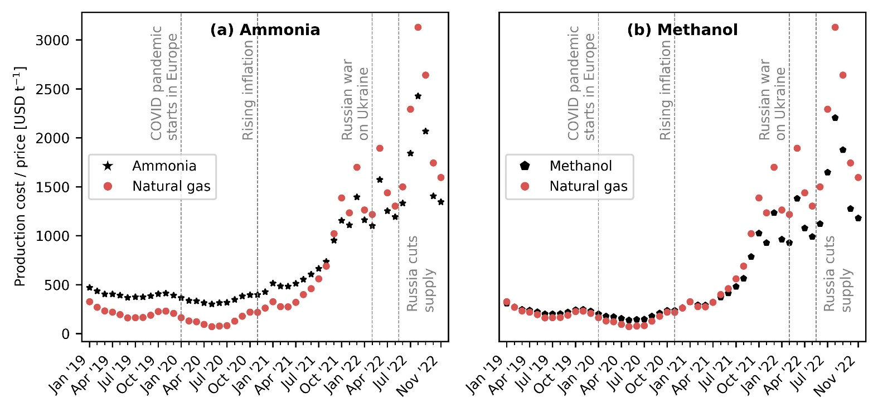
Fig. 1. Natural gas spot prices and production cost for fossil ammonia and methanol in Europe. (a) Fossil ammonia produced via the Haber-Bosch process with grey hydrogen from steam methane reforming (SMR) using natural gas as feedstock. (b) Fossil methanol synthesised from natural gas. The necessary information for the economic calculations (CAPEX and OPEX) comes from process simulations. Calculations were performed considering the effect of inflation and the monthly fluctuations in natural gas and electricity prices (the evolution of electricity prices in Europe is displayed in Supplementary Fig. SX). We validated our estimates with data from July 2019 to June 2022 for ammonia and from January 2015 to November 2022 for methanol (see Supplementary Fig. SX and SX, respectively). Notably, ammonia and methanol production costs have increased steadily since 2020, due to the rising inflation as a consequence of the COVID-19 pandemic, with a sharp increase since February 2022, after the Russian invasion of Ukraine.

Cost-competitive green ammonia and methanol due to the energy crisis
We next study the economic competitiveness of green production routes for ammonia and methanol, assuming a hydrogen cost linked to the specific technology deployed and a CO₂ cost from DAC linked to the natural gas and electricity price, considering in turn the impact of inflation on the utilities and capital expenditures. Green ammonia produced with hydrogen from water electrolysis using on-shore wind electricity turns cost-competitive at natural gas prices of around 1,700 USD t⁻¹. Hence, we find that green ammonia via wind-based electrolysis became cost-competitive relative to fossil ammonia from December 2021 to October 2022 for a period of six months (Fig. 2a), with production costs in the range from 1,290 to 1,590 USD t⁻¹ ammonia. In contrast, green ammonia via solar PV-based electrolytic hydrogen became competitive around the peak of natural gas spot prices in August 2022 (Fig. 2b). This is due to the higher cost of hydrogen from solar PV-based electrolysis, which shows a lower capacity factor compared to wind power (16.1 to 17.5%, for solar PV, vs. 35.6% to 39% for wind)²⁵. Ammonia production with blue hydrogen –SMR coupled with CCS– follows the same pattern as standard fossil ammonia, being slightly expensive than the conventional route due to the additional cost of CCS (Fig. 2c).
Green methanol produced with wind-based electrolytic hydrogen and DAC CO₂ becomes economically competitive at natural gas prices of around 3,100 USD t⁻¹ (Fig. 2d), with the break-even natural gas price largely depending again on the levelized cost of hydrogen. Thus, methanol production via this route became cost competitive only at the peak of natural gas prices in August 2022. Meanwhile, the solar PV-based route never became economically appealing (Fig. 2e). For the case of methanol production from DAC CO₂ and blue hydrogen, the cost of production was, on average, 182% higher than fossil methanol due to the additional cost of CCS and captured CO₂ (Fig. 2f).
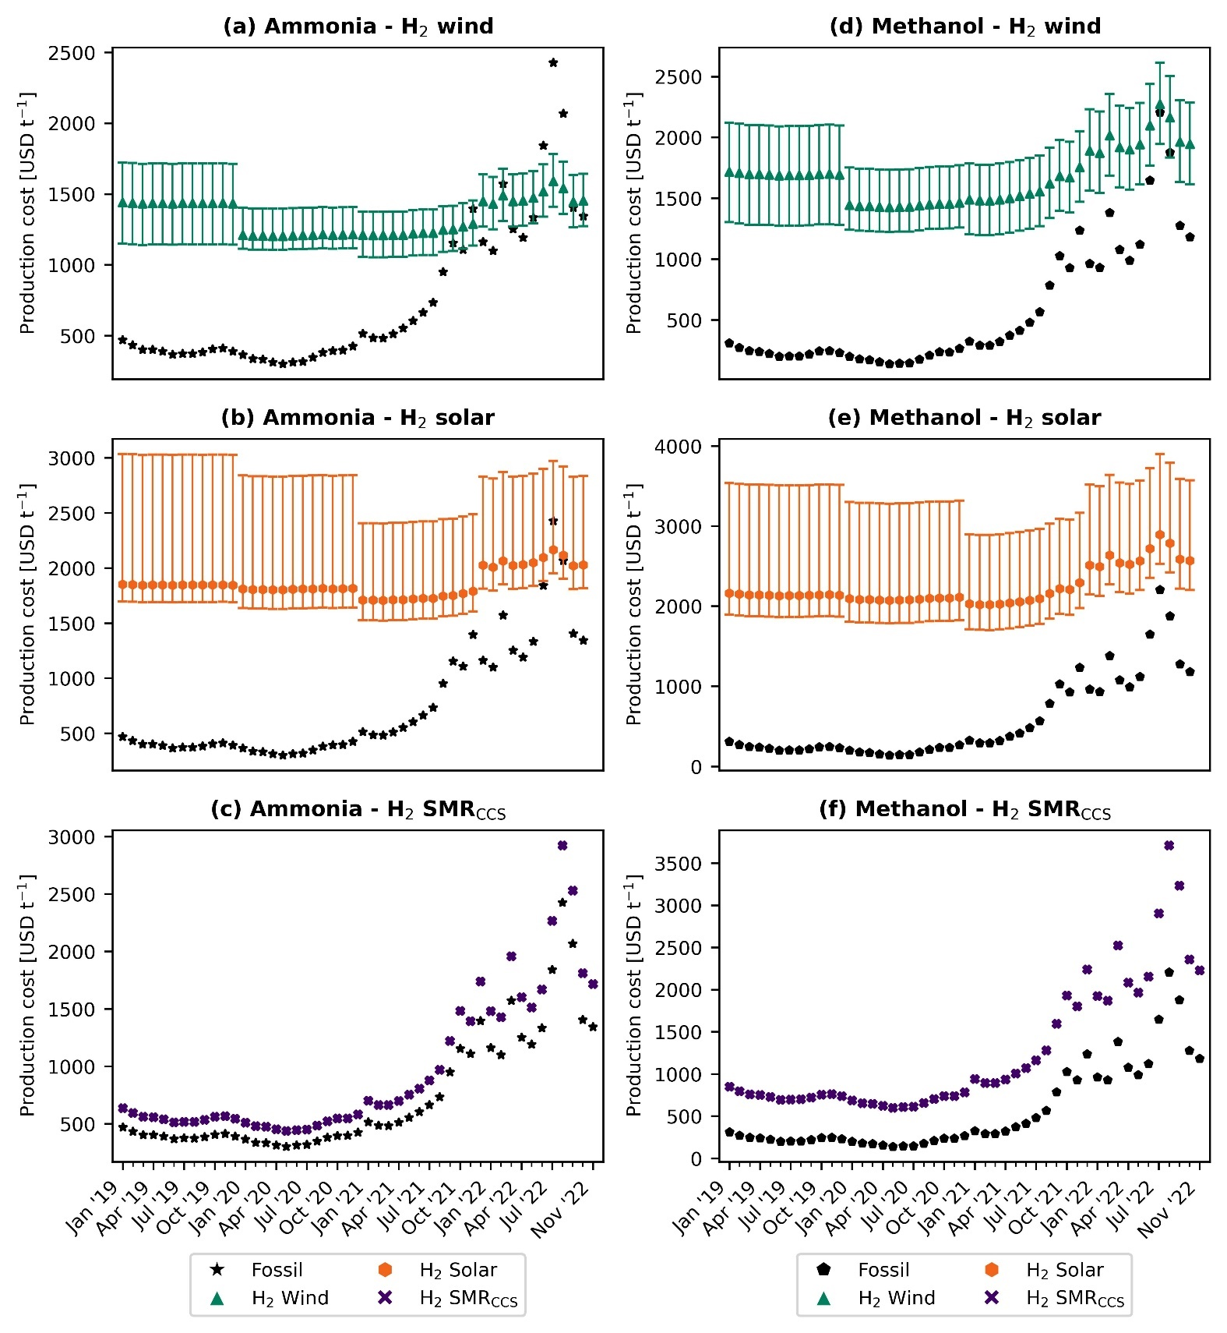
Fig. 2. Production cost for green ammonia and methanol in Europe compared with the fossil (natural gas-based) counterpart. Green ammonia produced via the Haber-Bosch process with green hydrogen from water electrolysis using on-shore wind electricity (a) or solar photovoltaic (PV) electricity (b) and blue hydrogen from steam methane reforming (SMR) coupled with carbon capture and storage (CCS) (c). Methanol synthesised from captured CO₂ and wind-based electrolytic hydrogen (d), PV-based electrolytic hydrogen (e) or blue hydrogen –SMR coupled with CCS– (f). As in Fig. 1, the calculations are based on rigorous simulations and consider the the effect of inflation and the monthly fluctuations in natural gas and electricity prices fluctuations (the evolution of electricity prices in Europe is displayed in Supplementary Fig. SX). Error bars display the production cost considering the lower and upper bound for the levelized cost of hydrogen. Notably, ammonia production via wind electrolysis arises as the most competitive green route, which has been cheaper than or similar to fossil ammonia for six months since December 2021.
We next analyse the breakdown of the production cost for fossil and green chemicals at different time points (Fig. 3). We focus on the green routes based on wind-based electrolytic hydrogen, as these were found to be the most promising routes (results for the other green routes are displayed in the Supplementary Fig. SX). Moreover, we take average values for the years 2019 and 2020 as the natural gas and electricity prices before July 2021 were almost constant.
Our results show that the contribution of natural gas to the production cost for fossil ammonia increased from 21% in 2020 to 44% in July 2021 and up to 63% in November 2022 (Fig. 3a). Similarly, for the production of fossil methanol, the share of natural gas increased from 48% in 2020 to 76% in July 2021 and 88% in November 2022 (Fig. 3b). For the green routes, hydrogen represents the highest share of the production cost; up to 69-85% for green ammonia and 61-67% for green methanol, depending on the time point. We estimate that the average European levelized cost of wind-based electrolytic hydrogen has decreased steadily from 5.2-8.5 USD kg⁻¹ in 2019 to 4.5-6.3 USD kg⁻¹ by 2021, primarily driven by a reduction in the cost of on-shore wind electricity from 67 to 42 USD MWh⁻¹, based on ref.²⁵. The hydrogen cost slightly increased in 2022 up to 5.2-7.3 USD kg⁻¹, due to the effect of inflation. Hence, the hydrogen cost applied in this work align well with the lower bound of previous literature estimates (i.e., between 4.6 and 10 USD kg⁻¹ based on ref.²⁶).
For green methanol, the CO₂ feedstock captured from the atmosphere by DAC accounted for about 16% of the production cost in 2020 and up to 28% in November 2022. The higher contribution can be attributed to the increased cost of DAC, from an average of 246 USD t⁻¹ CO₂ in 2019 to 360 USD t⁻¹ CO₂ in 2021, reaching the highest value of 775 USD t⁻¹ CO₂ in August 2022. Here, we consider a high-temperature solvent-based DAC technology, adapted from the work by Keith et al.²⁷. This technology requires around 0.1 t of natural gas and 77 kWh of electricity per t of CO₂ captured²⁷. Hence, the capture cost is highly sensitive to the fluctuation in natural gas and electricity prices. There are other DAC technologies, such as the low-temperature sorbent-based technology, that might be less dependent on natural gas²⁸.

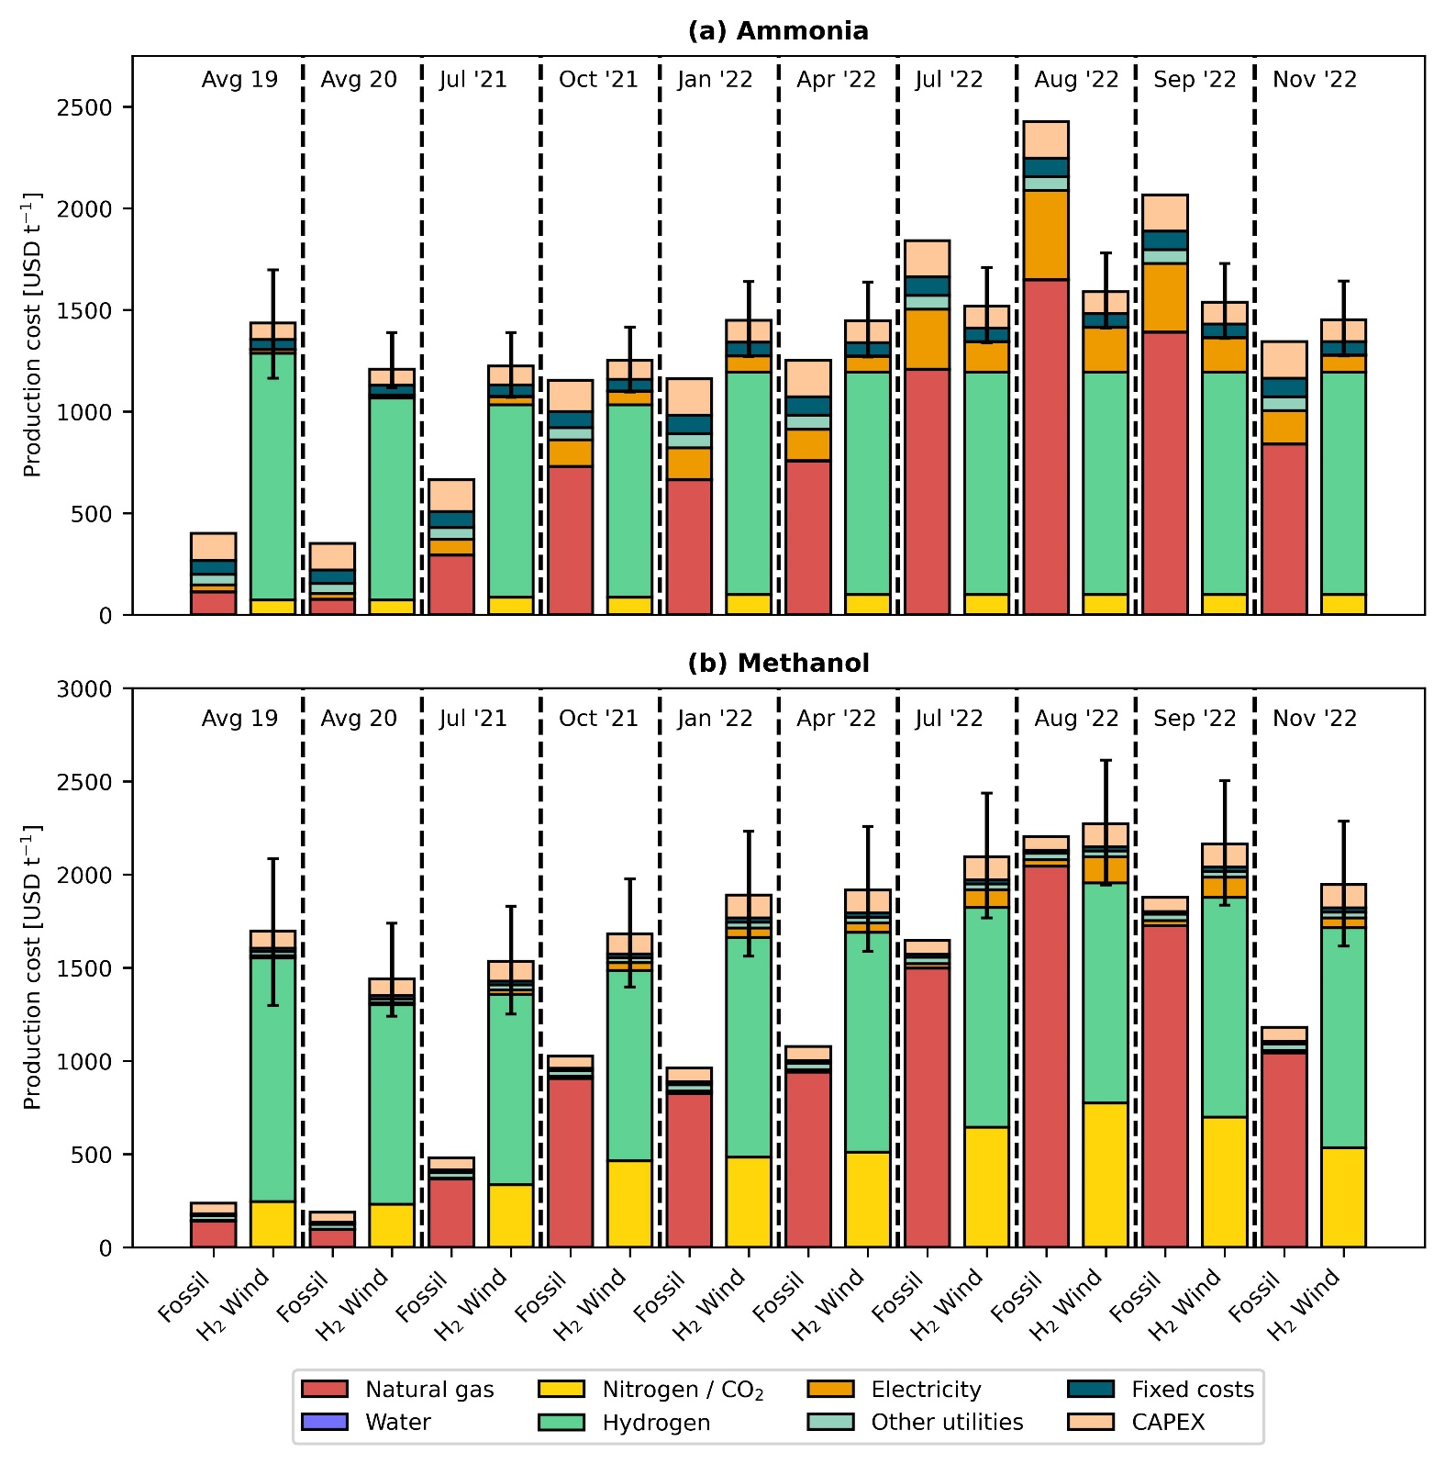
Fig. 3. Breakdown of production costs for fossil and green ammonia (a) and methanol (b). Only the green production routes based on hydrogen from water electrolysis using on-shore wind electricity are displayed, as these were found to be the most promising routes (the results for other green routes can be found in the Supplementary Fig. SX). Error bars display the production cost considering the lower and upper bound for the levelized cost of hydrogen. The contribution of natural gas to the average production costs has increased notably, from 21% in 2020 to 63% in November 2022 for ammonia and from 48% in 2020 to 88% in November 2022 for methanol. Hydrogen has the highest contribution to the average production cost of green chemicals.

Carbon mitigation becomes economically appealing due to expensive fossil feedstock
We finally analyse the avoidance cost of green ammonia and methanol, that is, to shed light on the economic appeal of climate change mitigation under high fossil feedstock prices. In 2020 at an average natural gas price of 145 USD t⁻¹, wind- and solar-based ammonia resulted in an avoidance cost of 572 and 1,388 USD t⁻¹ CO₂-eq, respectively (Fig. 4a). This cost was substantially higher for methanol, i.e., 1,435 and 7,696 USD t⁻¹ CO₂-eq, respectively (Fig. 4b) in the same period, primarily due to the wider economic gap between fossil and green methanol. Hence, the avoidance cost of green ammonia and methanol in 2020 was way above the removal cost of bioenergy with carbon capture and storage (BECCS) and DAC with carbon capture and storage (DACCS), two of the most prominent negative emissions technologies (NETs), forecasted at 100-200 USD t⁻¹ CO₂ and 100-300 USD t⁻¹ CO₂, respectively²⁹. However, at the peak of natural gas prices in 2022, the avoidance cost of green ammonia and methanol became negative, implying that mitigating carbon emissions via green ammonia and methanol became economically appealing. Specifically, the win-win scenario (economic and environmental competitiveness) emerged in July 2021, reaching potential economic savings of 56 to 558 USD t⁻¹ CO₂-eq avoided via the wind-based route for ammonia production, and in August 2022 for methanol via wind, with potential savings of 298 USD t⁻¹ CO₂-eq avoided if considering the lower end of the hydrogen cost range.
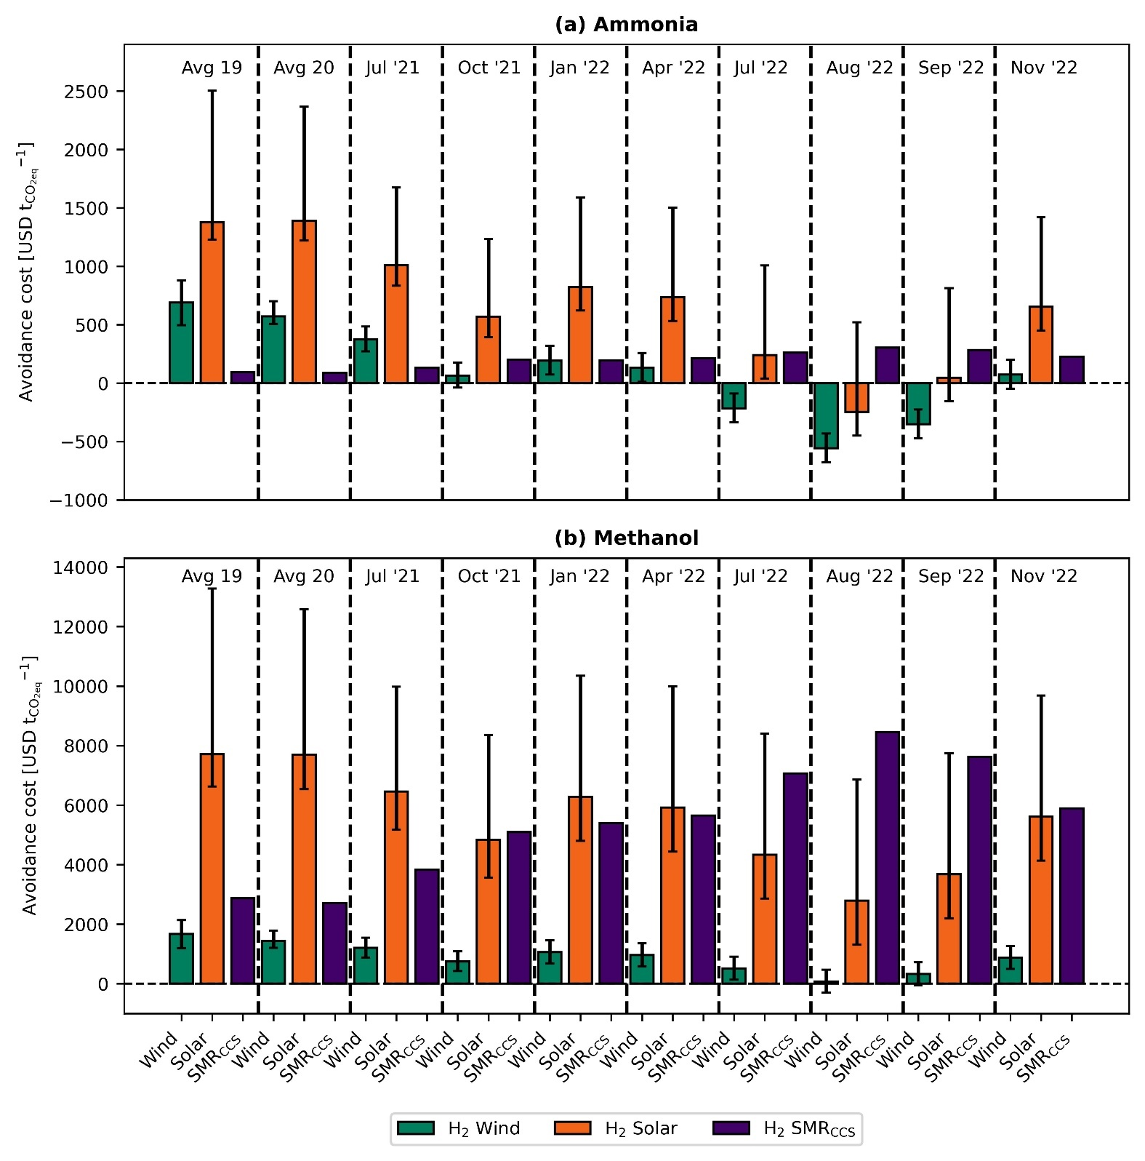
Fig. 4. Avoidance costs for green ammonia (a) and methanol (b) production routes. Error bars display the production cost considering the lower and upper bound for the levelized cost of hydrogen. A negative avoidance cost means that costs and greenhouse gas (GHG) emissions could be reduced simultaneously.

Discussion
The chemical sector is regarded as a hard-to-abate sector due to its strong reliance on fossil feedstock. There is currently a strong motivation to shift to renewable carbon, i.e., biomass, captured CO₂ and plastics waste, yet the alternative routes, particularly those based on CCU, are very expensive due to the electrolytic hydrogen needs. Here we show how an unprecedented crisis of soaring natural gas and electricity prices in Europe could radically change the current landscape and improve the economic competitiveness of low carbon chemicals based on green hydrogen, with green ammonia becoming up to 35% cheaper than its fossil counterpart and green methanol slightly more expensive (+3% above grey methanol).
Whether this situation will persist will depend on the evolution of the situation in Ukraine and the adopted measures to diversify gas suppliers (e.g., increased imports of more expensive liquified natural gas). Between December 2022 and January 2023, favourable weather and lower demand from the industry have led to a decline of the natural gas prices back to levels before the Russian invasion of Ukraine³⁰. In 2023, considering zero supply from Russia, unpredictable weather conditions, and increasing competition for liquified natural gas, securing natural gas supplies could be an obstacle³¹. The World Bank forecasts that natural gas prices will moderate in 2023 but remain well above the average prices registered before 2020²¹. Other sources³² predict that Europe's natural gas spot price will remain in the range of 1,579-2,216 USD t⁻¹. At the same time, the costs of renewable energy technologies are expected to decline due to technological advancements and the experience effect³³. It is estimated that the levelized cost of on-shore wind electricity will reduce from an average of 67 USD MWh⁻¹ in 2019 to 40 USD MWh⁻¹ by 2030, thereby reducing the levelized cost of hydrogen from 5.2-8.5 USD kg⁻¹ in 2019 to around 2.7 USD kg⁻¹ by 2030³⁴. Similarly, forecasts also indicate a strong decrease in the cost of solar PV-based electrolytic hydrogen and electrolysers over the next decade³³. Hence, it seems sensible to think that ammonia production from wind-based electrolytic hydrogen could be cost-competitive in the foreseeable future in Europe.
The production costs of chemicals have been historically higher in Europe than in other regions like U.S., Russia, or Saudi Arabia, primarily due to higher labour and feedstock costs³⁵. The disruption of the global energy market in 2022 has further exacerbated this gap since other regions have faced less fluctuation in energy prices due to lower dependence on imports²¹. For example, between 2020 and 2022, the natural gas price increased by a factor of 1.6 in the U.S. compared with 9.6 in Europe²¹. Within this context, the chemical industry will be forced to shift production to regions with low-cost labour and feedstocks instead of deploying domestic green production routes. However, such relocation would have very strong socio-economic implications for Europe. In 2020, Europe was the second largest chemicals producer in the world³⁶. Given the pivotal role of chemicals across many supply chains, shifting production would likely weaken Europe’s leading role in chemicals production while exposing Europe to the vulnerability of supply disruption. This would be particularly critical in the case of ammonia, an essential product to ensure food security⁵. Moreover, chemical companies generate about 1.2 million jobs across Europe³⁶, which would face an uncertain scenario.
In accordance with the Paris Climate Accords, Europe has set targets to reduce emissions by 55% by 2030 and become a net-zero GHG emitting continent by 2050³⁷. In order to achieve these ambitious targets, Europe needs to invest majorly in low-carbon infrastructure. A recent study found that the current pace of investment and development of these technologies is insufficient to meet the targets³⁸. An additional investment of approximately 94 billion USD yr⁻¹ is required in the immediate future until 2025 in order to achieve the net-zero target by 2050. It was also found that a tremendous investment increase of 26 billion USD yr⁻¹ was needed for renewable power plants, especially solar (7.6 billion USD yr⁻¹) and on-shore wind (17.3 billion USD yr⁻¹)³⁸. Therefore, negative mitigation costs associated with the production of green ammonia and methanol (especially on-shore wind-based ammonia) appear as particularly appealing to lower the carbon footprint of these essential chemicals driven by market forces rather than by incentives. Hence, in addition to improving supply security, green ammonia and methanol could help the European chemical industry curb GHG emissions at a negative mitigation cost, in contrast to expensive NETs, which also face socio-political challenges.
Our findings suggest that rising energy prices in Europe can make green ammonia and methanol production routes cost-competitive, thereby overcoming the primary barrier to their implementation. The current scenario represents a unique opportunity for the European chemical industry to start shifting to renewable feedstocks to reduce costs and GHG emissions simultaneously. Such a transition would also benefit European economies by establishing an adequate supply of essential commodities (i.e., ammonia) and supporting the energy transition (i.e., methanol). Moreover, by locally producing renewable feedstocks (i.e., hydrogen and captured CO₂), Europe would further reduce its dependence on imports and its vulnerability to market shocks. However, the debate remains open concerning the potential future reliance of Europe on critical raw material imports to realize a complete transition towards renewable energy technologies³⁹.

Methods
Ammonia production routes. The fossil and green ammonia routes are based on D’Angelo et al.⁹. For fossil ammonia, natural gas and water are mixed and heated to 858 °C and fed to a SMR unit where natural gas is converted to carbon monoxide and hydrogen (syngas). The output from the SMR is then fed into an autothermal reformer (ATR) along with air (78% nitrogen, 21% oxygen, and 1% argon). The oxygen in the air reacts with the residual methane and increases the temperature to 1,200 °C inside the ATR. The output from the ATR is cooled to 400 °C and sent to a series of water-gas-shift (WGS) reactors to convert carbon monoxide to CO₂. The first one operates at a high temperature (261 °C), i.e., high-temperature water-gas-shift (HTWGS) reactor. The output stream from the HTWGS is fed to a low-temperature water-gas-shift (LTWGS) reactor, which operates at 50 °C. The output stream from the WGS reactors is rich in CO₂, which needs to be removed. This is done in an absorption column using a lean solvent stream with a composition of 90% water and 10% monoethanolamine (MEA) where 99.7% of the input CO₂ is absorbed and removed in the liquid stream. The residual carbon monoxide and CO₂ are eliminated to avoid poisoning the catalyst in the Haber-Bosch process⁴⁰. Accordingly, a methanation unit converts the residual carbon oxides to methane. In the Haber-Bosch process, the CO₂ and carbon monoxide free stream are then compressed to 196 bar, mixed with the recycle stream, and sent to a flash separator. This stream is then sent to a series of three reactors where nitrogen and hydrogen react to produce ammonia. As mentioned previously, the outlet stream from these three reactors is cooled and mixed with the fresh feed and sent to a flash unit. The liquid stream from this flash is rich in ammonia, which is further purified with a pair of flash separators to meet industrial standards (99.6%). For the production of ammonia using green hydrogen (electrolytic hydrogen using wind or solar electricity) and blue hydrogen (SMR coupled with CCS), nitrogen from cryogenic air separation and hydrogen is mixed in the ratio 1:3 and sent to the Haber-Bosch process described earlier. A Proton Exchange Membrane (PEM) electrolyser with a stack lifetime of 60,000 hours is considered for producing green hydrogen via water electrolysis.
Methanol production routes. The fossil and green production routes for methanol are based on González-Garay et al.¹⁰. Fossil methanol is produced from syngas from natural gas via SMR. Syngas is then compressed to 110 bar, mixed with the recycle streams and then heated to 150 °C before being fed to a plug-flow reactor where syngas is converted to methanol following the kinetic model in Bussche and Froment⁴¹. The output stream from the reactor is cooled to 38 °C and sent to a flash separator. A small portion of the gas stream from the flash separator is purged whereas the rest is pressurized to 110 bar and recycled. The liquid stream from the flash separator is expanded to 2 bar and sent to a second flash unit, where the gas stream is again pressurized to 110 bar and recycled, and the liquid stream is sent to a distillation column. The distillation column separates liquid methanol (at the condenser) with a purity of 99.9% and water (at the bottom). To produce methanol using green and blue hydrogen, CO₂ from DAC and hydrogen is mixed with the recycle streams, compressed to 50 bar, and heated to 180-280 °C. This stream is then sent to a reactor where, the reverse water-gas-shift (RWGS) reaction takes place, converting CO₂ to carbon monoxide, which is consequently hydrogenated to methanol. Similar to fossil methanol, the outlet from the reactor is sent to a series of two flash separators where the gas stream from the first flash is recycled (with a purge). The liquid stream from the second flash unit is sent to a distillation column which recovers methanol at a purity of 99.9%. The CO₂ fed to the reactor is obtained via the DAC technology adapted from the work by Keith et al.²⁷. Here, aqueous potassium hydroxide (KOH) is used as a sorbent and a caustic calcium cycle is implemented for the regeneration of KOH. However, energy from natural gas is required for the calciner in the recovery cycle. Around 0.11 tons of natural gas is required per ton of CO₂ captured²⁷.

Economic assessment. The production costs of fossil and green ammonia and methanol routes were calculated from the operational and capital expenditures (OPEX and CAPEX) and fixed production costs. The OPEX accounts for feedstock and other raw materials and utilities. The CAPEX accounts for the equipment cost, and the fixed costs consider the labour and maintenance costs in addition to overhead expenses and interest. The detailed procedure adapted for the economic assessment is described in detail in Supplementary section X.
Avoidance costs. The avoidance cost for each green chemical in as follows:
$$\text{AC} \text{= }\frac{{\text{PC}}_{\text{Green}}\text{ - }{\text{PC}}_{\text{Fossil}}}{{\text{CF}}_{\text{Fossil}}\text{ - }{\text{CF}}_{\text{Green}}}\text{ (Equation 1)}$$
where $AC$ is the avoidance cost in USD t⁻¹ CO₂-eq, ${\text{PC}}_{\text{Fossil/}\text{Green}}$represents the production cost in USD t⁻¹ for the fossil and green routes, and ${\text{CF}}_{\text{Fossil/}\text{Green}}$ represents the carbon footprint in t CO₂-eq t⁻¹.
We estimate the chemicals carbon footprint with an attributional life cycle assessment (LCA) in accordance with the ISO 14040/14044 standards^{42,43}. LCA quantifies environmental impacts over the life cycle of products, from raw materials extraction to end-user disposal⁴⁴. The functional unit for the LCA is defined as “the production of 1 kg chemicals (ammonia or methanol)”. The scope of the assessment is cradle-to-gate, meaning that the burdens considered cover all the stages from the extraction of raw materials (e.g., natural gas) until the production of the chemicals. We omit the use phase since it is assumed that impacts are the same for the fossil and green chemicals. The mass and energy flows for the production routes were primarily obtained from D’Angelo et al.⁹ and González-Garay et al.¹⁰, as described above. Data for the background system (e.g., natural gas and electricity supply) were obtained from the Ecoinvent v3.5 database⁴⁵. Regarding the climate impact assessment, we consider the 100-year global warming potentials (GWPs) as implemented in the ReCiPe 2016 methodology⁴⁶.

References
1 IEA, The Future of Petrochemicals: Towards more sustainable plastics and fertilisers, International Energy Agency, 2018.
2 F. Bauer, J. P. Tilsted, S. Pfister, C. Oberschelp and V. Kulionis, Current Opinion in Chemical Engineering, 2023, 39, 100881.
3 F. Bauer, V. Kulionis, C. Oberschelp, S. Pfister, J. P. Tilsted, G. D. Finkill and S. Fjäll, Petrochemicals and Climate Change: Tracing Globally Growing Emissions and Key Blind Spots in a Fossil-Based Industry, Lund University, Lund, 2022.
4 J. W. Erisman, M. A. Sutton, J. Galloway, Z. Klimont and W. Winiwarter, Nature Geosci, 2008, 1, 636–639.
5 L. Rosa and P. Gabrielli, Environ. Res. Lett., 2022, 18, 014008.
6 G. A. Olah, Angewandte Chemie International Edition, 2005, 44, 2636–2639.
7 IEA, Ammonia Technology Roadmap: Towards more sustainable nitrogen fertiliser production, OECD, 2021.
8 IRENA, Innovation Outlook: Renewable Methanol, 2021.
9 S. C. D’Angelo, S. Cobo, V. Tulus, A. Nabera, A. J. Martín, J. Pérez-Ramírez and G. Guillén-Gosálbez, ACS Sustainable Chem. Eng., 2021, 9, 9740–9749.
10 A. González-Garay, M. S. Frei, A. Al-Qahtani, C. Mondelli, G. Guillén-Gosálbez and J. Pérez-Ramírez, Energy Environ. Sci., 2019, 12, 3425–3436.
11 Z. J. Schiffer and K. Manthiram, Joule, 2017, 1, 10–14.
12 J.-P. Lange, Energy Environ. Sci., 2021, 14, 4358–4376.
13 F. Ausfelder, E. O. Herrman and L. F. López González, Technology options for CO2-emission reduction of hydrogen feedstock in ammonia production, DECHEMA Gesellschaft für Chemische Technik und Biotechnologie e.V, 2022.
14 IEA, Technology Roadmap Energy and GHG Reductions in the Chemical Industry via Catalytic Processes, International Energy Agency, 2013.
15 J. Huo, Z. Wang, C. Oberschelp, G. Guillén-Gosálbez and S. Hellweg, Green Chem., 2023, 25, 415–430.
16 Á. Galán-Martín, V. Tulus, I. Díaz, C. Pozo, J. Pérez-Ramírez and G. Guillén-Gosálbez, One Earth, 2021, 4, 565–583.
17 I. Ioannou, Á. Galán-Martín, J. Pérez-Ramírez and G. Guillén-Gosálbez, Energy Environ. Sci., , DOI:10.1039/D2EE01153K.
18 A. Kätelhön, R. Meys, S. Deutz, S. Suh and A. Bardow, Proceedings of the National Academy of Sciences, 2019, 116, 11187–11194.
19 C. Hepburn, E. Adlen, J. Beddington, E. A. Carter, S. Fuss, N. Mac Dowell, J. C. Minx, P. Smith and C. K. Williams, Nature, 2019, 575, 87–97.
20 P. Heather, European Traded Gas Hubs: the supremacy of TTF, The Oxford Institute for Energy Studies, 2022.
21 The World Bank, Commodity Markets Outlook: The Impact of the War in Ukraine on Commodity Markets, The World Bank Group, Washington DC, 2022.
22 cefic, Chemical Monthly Report (CMR) - High energy prices and economic uncertainty continue to drive down the chemicals output in the EU27 area, European Chemical Industry Council, 2022.
23 A. de Sousa, S. Gebre and S. Treloar, Bloomberg.com, 2022.
24 J. Lopez, EPCA ’22, https://www.icis.com/explore/resources/news/2022/10/04/10811649/epca-22-european-shut-ammonia-production-unlikely-to-return-analyst, (accessed December 9, 2022).
25 IRENA, Making the breakthrough: Green hydrogen policies and technology costs, International Renewable Energy Agency, Abu Dhabi, 2021.
26 B. Parkinson, P. Balcombe, J. F. Speirs, A. D. Hawkes and K. Hellgardt, Energy Environ. Sci., 2019, 12, 19–40.
27 D. W. Keith, G. Holmes, D. St. Angelo and K. Heidel, Joule, 2018, 2, 1573–1594.
28 S. Cobo, Á. Galán-Martín, V. Tulus, M. A. J. Huijbregts and G. Guillén-Gosálbez, Nat Commun, 2022, 13, 2535.
29 S. Fuss, W. F. Lamb, M. W. Callaghan, J. Hilaire, F. Creutzig, T. Amann, T. Beringer, W. de O. Garcia, J. Hartmann, T. Khanna, G. Luderer, G. F. Nemet, J. Rogelj, P. Smith, J. L. V. Vicente, J. Wilcox, M. del M. Z. Dominguez and J. C. Minx, Environ. Res. Lett., 2018, 13, 063002.
30 The World Bank, Commodity Markets, https://www.worldbank.org/en/research/commodity-markets, (accessed January 12, 2023).
31 IEA, How to Avoid Gas Shortages in the European Union in 2023, 2022.
32 CME Group, Dutch TTF Natural Gas Calendar Month Futures Quotes, https://www.cmegroup.com/markets/energy/natural-gas/dutch-ttf-natural-gas-calendar-month.quotes.html, (accessed January 9, 2023).
33 R. Way, M. C. Ives, P. Mealy and J. D. Farmer, Joule, 2022, 6, 2057–2082.
34 T. N. Do, C. You and J. Kim, Energy Environ. Sci., 2022, 15, 169–184.
35 A. Boulamanti and J. A. Moya, Renewable and Sustainable Energy Reviews, 2017, 68, 1205–1212.
36 cefic, The European Chemical Industry - Facts & Figures 2022, 2022.
37 European Commission, “Fit for 55”: delivering the EU’s 2030 Climate Target on the way to climate neutrality, COM(2021) 550 final, Brussels, 2021.
38 L. Klaaßen and B. Steffen, Nat. Clim. Chang., 2023, 1–9.
39 B. K. Sovacool, S. H. Ali, M. Bazilian, B. Radley, B. Nemery, J. Okatz and D. Mulvaney, Science, 2020, 367, 30–33.
40 M. Appl, in Ullmann’s Encyclopedia of Industrial Chemistry, John Wiley & Sons, Ltd, 2011.
41 K. M. V. Bussche and G. F. Froment, Journal of Catalysis, 1996, 161, 1–10.
42 ISO 14040:2006, Environmental management — Life cycle assessment — Principles and framework, .
43 ISO 14044:2006, Environmental management — Life cycle assessment — Requirements and guidelines, .
44 S. Hellweg and L. Milà i Canals, Science, 2014, 344, 1109–1113.
45 G. Wernet, C. Bauer, B. Steubing, J. Reinhard, E. Moreno-Ruiz and B. Weidema, Int J Life Cycle Assess, 2016, 21, 1218–1230.
46 M. A. J. Huijbregts, Z. J. N. Steinmann, P. M. F. Elshout, G. Stam, F. Verones, M. Vieira, M. Zijp, A. Hollander and R. van Zelm, Int J Life Cycle Assess, 2017, 22, 138–147.

